|  |
| --- |
| Serial No: |
| **Final Exam**  **Part II** |
| **Total Time: 2 Hour** |
| **Total Marks: 80** |
| ________________  Signature of Invigilator |

|  |
| --- |
| **EE-227 Digital**  **Logic Design** |
|  |
| Friday, May 12, 2017 |
| **Course Instructor(s)** |
| Dr. Mehwish Hassan, Ms Mehreen Alam and Mr. Jawad Hassan |

|  |
| --- |
| **______________________________ _________ ______ _____________________**  Student NameRoll No Section Signature |
|  |

## DO NOT OPEN THE QUESTION BOOK OR START UNTIL INSTRUCTED.

**Instructions:**

1. Attempt on question paper. Attempt all of them. Read the question carefully, understand the question, and then attempt it.
2. No additional sheet will be provided for rough work. Use and mark the back of the last page for rough work.
3. If you need more space write on the back side of the paper and clearly mark question and part number etc.
4. After asked to commence the exam, please verify that you have **13 pages** different printed pages including this title page. There are total of **3 Questions**.
5. **Calculator is NOT allowed**.
6. Use permanent ink pens only. Any part done using soft pencil will not be marked and cannot be claimed for rechecking.
7. **For each question show your complete method in solution**.

|  |  |  |  |  |
| --- | --- | --- | --- | --- |
|  | **Q-1** | **Q-2** | **Q-3** | **Total** |
| **Marks Obtained** |  |  |  |  |
| **Total**  **Marks** | **20** | **36** | **24** | **80** |

**Question # 1 [12 + 8 = 20]**

1. Design a combinational circuit that converts four bit Gray code to 8,4,-2,-1. [12]
2. Draw and label the circuit diagram of a universal shift register. The shift register should operate according to the following table. [8]

|  |  |  |
| --- | --- | --- |
| **S1** | **S0** | **Operation** |
| 0 | 0 | Reset to 0 |
| 0 | 1 | Shift left |
| 1 | 0 | Parallel Load |
| 1 | 1 | Complement the output |

**Question # 2 [14 + 12 + 10 = 36]**

1. Design a sequential circuit by using following state transition diagram. Use JK Flip flops and treat unused states as don't cares. [14]
2. Perform state reduction for the following state diagram. Give the reduced state table and state diagram. [12]

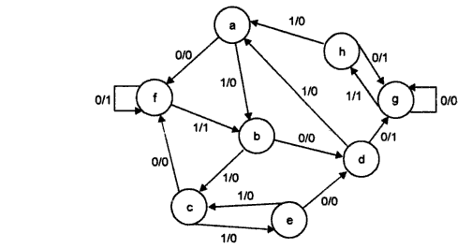

1. A **TR** Flip Flop has four operations complement, set to 1, clear to zero and no change when inputs T and R are 00, 01, 10 and 11 respectively. you have to give:
   1. characteristic table of TR flip flop [2]
   2. Characteristic equation of TR flip flop [2]
   3. Excitation table of TR flip flop [2]
   4. Implement D flip flop with TR flip flop [4]

**Question # 3 [10 + 14 = 24]**

1. Implement a combinational circuit using the ROM below. The circuit takes a three bit input number (A2, A1, A0) and outputs three bit number (B2, B1, B0). Output number will be Input **number + 3** if number is less than or equal to 4 otherwise outputs same input.

Clearly label the ROM. Also draw ROM table. [10]

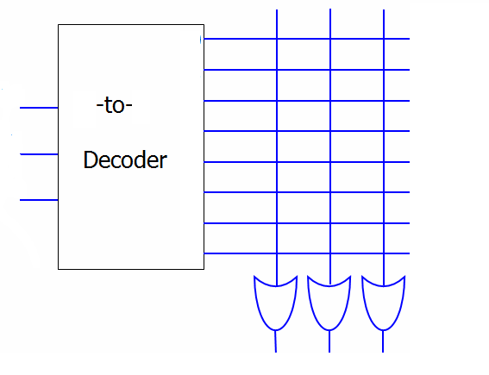

1. Implement the following functions using a PLA by using minimum number of product terms. Give PLA table, draw and label the PLA diagram clearly showing all the connections. [14]

A(w,x,y,z) = Σ (0,1,5,6,8,9,13,14)

B(w,x,y,z) = Σ (1,3,4,5,6,7,11,12,15)

C(w,x,y,z) = Σ (1,3,4,5,6,7,11,15)

D(w,x,y,z) = Σ (0,2,3,5,6,7,8,10,11,13,14,15)

**Rough Work**